Cash Plus, Safety Plus? Intimate Partner Violence and Productive Inclusion in Mauritania

Empirical strategy & Results

IBRAHIM KASSOUM Habibou

29 May 2025

1. Some concerns 1

2. Causal Forest for heterogeneity analysis of IPV 1

2.1. Model estimation and Plot 1

2.2. Estimates 1

2.3. Random forest for variable importance. 1

2.4. Table for variable importance 1

2.4.1. Tekavoul 1

2.4.2. Productive inclusion 1

2.4.3. Other tables 1

2.5. Estimates of treatment effect 1

2.5.1. Controlling Behavior 1

2.5.2. Emotional Violence 1

2.5.3. Physical violence 1

2.5.4. Sexual Violence 1

2.5.5. Economic Violence 1

2.5.6. Other types of violences 1

2.6. Mechanism 1

2.6.1. Economic Security & Emotional Well-being 1

2.6.2. Intra-household Conflict 1

2.6.3. Women’s bargaining power 1

2.6.4. Intensive time use 1

# Some concerns

* Why Manuela use the baseline values of the control variables for the IPV instead of the followup-value for the control group (to prevent spill over effect ??)
* I remove the row with missing data in any of the IPV outcome variables.
* All variables can’t be used in the algorithm as some can explain the results just by pur chance. With all baseline variables t
* A Recursive Feature Elimination (RFE) is used to select features.
  + RFE is a feature selection technique that iteratively removes features based on their importance, aiming to find the optimal subset of features that provides the best model performance. It starts with a model trained on all features, then calculates feature importances, and removes the least important ones. This process is repeated until the desired number of features is reached or the model performance stops improving.
* I use Knn algorithm to impute missing values in the features of the training dataset. The same algorythm can be use to complete the for the prediction dataset (it is important so that we can adapt the number). The *mean* function is used as the aggregation
  + the Euclidean distance
  + 10 neigbor
* source: <https://livebook.datascienceheroes.com/selecting-best-variables.html#general_aspects_selecting_best_variables>

# Causal Forest for heterogeneity analysis of IPV

## Model estimation and Plot

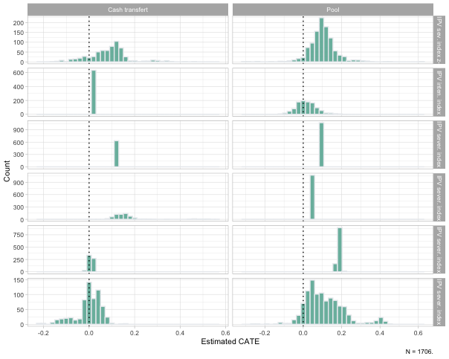

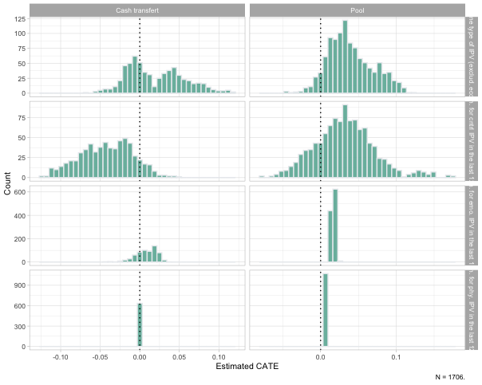

## Estimates (all IPV sev index)

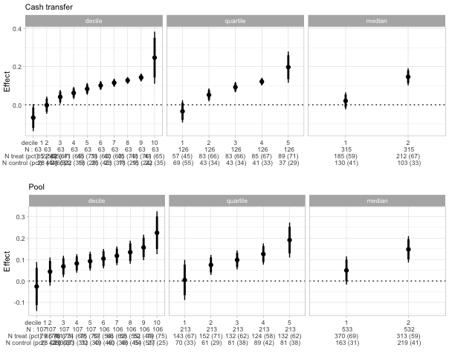

## Random forest for variable importance.

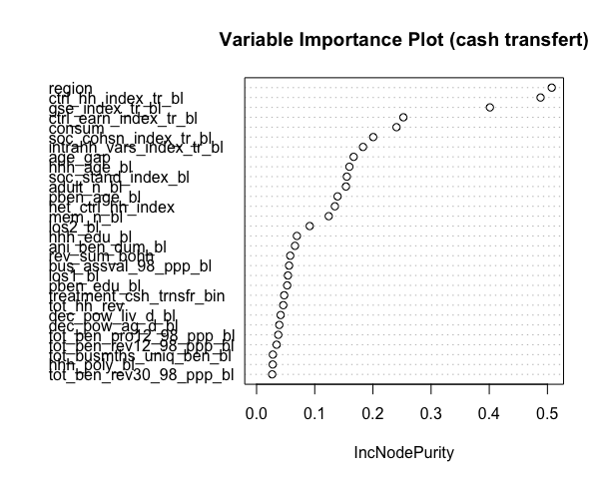

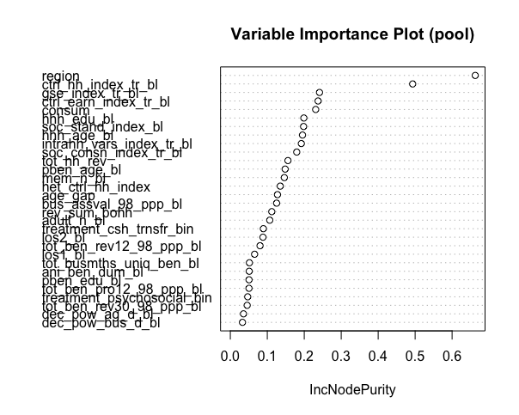

## Table for variable importance

### Tekavoul

| **Table : Balance Table** | | | | | | | | |
| --- | --- | --- | --- | --- | --- | --- | --- | --- |
| Variable | (1)  Control  N = 233 | (2)  Below Med.  N = 185 | (3)  Above Med.  N = 212 | (1)-(2) | (1)-(3) | (3)-(2) | Joint F-test   P-value | Pooled F-test   P-value |
| Benef. of cash transfert only (0,1) | 0.00(0.00) | 1.00(0.00) | 1.00(0.00) | -1*** | -1*** |  |  | 1*** |
| Benef. of capital (0,1) | 0.00(0.00) | 0.00(0.00) | 0.00(0.00) |  |  |  |  |  |
| Benef. of psychosocial package (0,1) | 0.00(0.00) | 0.00(0.00) | 0.00(0.00) |  |  |  |  |  |
| Benef. of full package (0,1) | 0.00(0.00) | 0.00(0.00) | 0.00(0.00) |  |  |  |  |  |
| Benef. is HH head | 0.37(0.48) | 0.28(0.45) | 0.50(0.50) | 0.098* | -0.128*** | 0.223*** | 20.103*** | 0.026 |
| Benef. is handicapped | 0.00(0.07) | 0.01(0.10) | 0.01(0.10) | -0.226 | -0.192 | -0.034 | 0.019 | 0.171 |
| Female (hh. head) | 0.40(0.49) | 0.29(0.46) | 0.53(0.50) | 0.116** | -0.134*** | 0.246*** | 25.254*** | 0.021 |
| Female (benef.) | 0.95(0.21) | 0.99(0.10) | 1.00(0.07) | -0.298*** | -0.404*** | 0.202 | 0.462 | 0.425*** |
| Polygamy (hh. head) | 0.09(0.28) | 0.09(0.29) | 0.06(0.23) | -0.019 | 0.109 | -0.13 | 1.763 | -0.042 |
| Polygamy (benef.) | 0.05(0.21) | 0.08(0.27) | 0.03(0.18) | -0.125 | 0.091 | -0.212** | 3.425* | 0.027 |
| Age (Hh. head) | 45.20(11.94) | 45.69(14.45) | 40.06(11.27) | -0.001 | 0.009*** | -0.008*** | 18.327*** | -0.004** |
| Age (benef.) | 35.80(11.42) | 35.61(9.87) | 34.41(8.71) | 0 | 0.003 | -0.003 | 1.628 | -0.002 |
| Age gap (hh. head - benef.) | 9.40(10.89) | 10.08(13.24) | 5.66(9.05) | -0.001 | 0.009*** | -0.008*** | 14.684*** | -0.003* |
| Age gap (hh. head - benef.) above med. (0,1) | 0.61(0.49) | 0.69(0.47) | 0.49(0.50) | -0.078 | 0.129*** | -0.205*** | 17.109*** | -0.033 |
| Education (years, HH head) | 1.22(2.94) | 1.13(2.72) | 0.91(2.14) | 0.003 | 0.012 | -0.009 | 0.816 | -0.007 |
| Education (years, benef.) | 0.91(2.12) | 0.65(1.58) | 0.80(1.77) | 0.017 | 0.007 | 0.013 | 0.722 | -0.012 |
| Primary education (0/1, H-hh. head) | 0.06(0.24) | 0.05(0.23) | 0.02(0.15) | 0.027 | 0.223** | -0.209* | 2.4 | -0.118 |
| Primary education (0/1, benef.) | 0.03(0.16) | 0.01(0.07) | 0.01(0.10) | 0.305** | 0.231 | 0.134 | 0.221 | -0.301* |
| Literate (hh. head) | 0.28(0.45) | 0.30(0.46) | 0.33(0.47) | -0.017 | -0.05 | 0.033 | 0.365 | 0.032 |
| Literate (benef.) | 0.24(0.43) | 0.18(0.38) | 0.21(0.41) | 0.091 | 0.04 | 0.053 | 0.723 | -0.061 |
| Control over earnings | -0.14(1.01) | -0.32(1.17) | 0.16(0.90) | 0.038 | -0.08*** | 0.107*** | 21.01*** | 0.016 |
| Control over earnings above med. (0,1) | 0.42(0.50) | 0.35(0.48) | 0.58(0.49) | 0.076 | -0.16*** | 0.233*** | 22.837*** | 0.048 |
| Control over hh. resources | -0.16(0.92) | -0.38(1.02) | 0.22(0.85) | 0.057** | -0.117*** | 0.156*** | 39.736*** | 0.026 |
| Control over hh. resources above med. (0,1) | 0.38(0.49) | 0.32(0.47) | 0.60(0.49) | 0.058 | -0.226*** | 0.279*** | 33.601*** | 0.091** |
| Intra hh. dynamics index | -0.12(1.10) | -0.13(0.93) | -0.08(1.03) | 0.003 | -0.01 | 0.015 | 0.355 | 0.004 |
| Intra hh. dynamics index above med. (0,1) | 0.51(0.50) | 0.45(0.50) | 0.54(0.50) | 0.052 | -0.031 | 0.083* | 2.774* | -0.007 |
| Self efficacy | 0.05(0.83) | 0.19(1.11) | -0.07(0.93) | -0.038 | 0.038 | -0.061** | 6.247** | 0.001 |
| Social cohesion and closeness to community | 0.04(1.02) | 0.19(1.04) | -0.06(0.86) | -0.034 | 0.028 | -0.067*** | 6.452** | 0.004 |
| Social standing | -0.06(0.96) | -0.04(1.15) | -0.16(0.80) | -0.005 | 0.032 | -0.032 | 1.543 | -0.011 |
| Partner inclusiveness (1-4) | 3.32(0.77) | 3.30(0.68) | 3.39(0.70) | 0.009 | -0.03 | 0.044 | 1.478 | 0.012 |
| Community inclusiveness (1-4) | 2.56(0.85) | 2.52(0.87) | 2.53(0.78) | 0.015 | 0.011 | 0.005 | 0.029 | -0.012 |
| Ben. revenue tot. | 94.06(320.98) | 192.70(788.94) | 110.89(446.66) | 0*** | 0 | 0 | 1.555 | 0* |
| Household in Sélibaby (0,1) | 0.30(0.46) | 0.06(0.25) | 0.69(0.46) | 0.372*** | -0.383*** | 0.648*** | 289.194*** | 0.094** |
| Tot. hh. revenue | 175.82(685.98) | 344.32(1,151.13) | 146.00(588.79) | 0** | 0 | 0*** | 4.473** | 0 |
| Consumption eq ppp | 3.31(1.70) | 2.69(1.74) | 3.35(1.61) | 0.05*** | -0.004 | 0.057*** | 15.141*** | -0.021* |
| Nbr of adults age 15+ in hh. | 3.76(3.28) | 3.89(3.34) | 2.89(1.84) | -0.003 | 0.029*** | -0.034*** | 13.121*** | -0.011 |
| Nbr hh. members | 8.59(5.68) | 9.18(6.37) | 7.56(3.87) | -0.004 | 0.011** | -0.015*** | 9.138*** | -0.002 |
| Own earnings influence (0,1) | 0.81(0.40) | 0.79(0.41) | 0.92(0.27) | 0.027 | -0.235*** | 0.268*** | 13.615*** | 0.09* |
| Can Decide to Earn Alone (0,1) | 0.80(0.40) | 0.80(0.40) | 0.92(0.26) | 0.004 | -0.254*** | 0.268*** | 12.926*** | 0.112** |
| Agriculture influence (0,1) | 0.68(0.47) | 0.74(0.44) | 0.77(0.42) | -0.067 | -0.119** | 0.052 | 0.783 | 0.091** |
| Livestock influence (0,1) | 0.43(0.50) | 0.42(0.50) | 0.55(0.50) | 0.008 | -0.123** | 0.13*** | 6.797*** | 0.058 |
| Off-farm business influence (0,1) | 0.67(0.47) | 0.57(0.50) | 0.70(0.46) | 0.102** | -0.043 | 0.146*** | 7.876*** | -0.026 |
| Daily spending influence (0,1) | 0.85(0.36) | 0.89(0.32) | 0.96(0.20) | -0.078 | -0.302*** | 0.253*** | 6.831*** | 0.188*** |
| Can Decide to Spend Alone (0,1) | 0.86(0.35) | 0.88(0.32) | 0.96(0.19) | -0.049 | -0.31*** | 0.289*** | 8.892*** | 0.171** |
| Large purchases influence (0,1) | 0.84(0.37) | 0.86(0.34) | 0.94(0.24) | -0.046 | -0.244*** | 0.212** | 6.003** | 0.14** |
| Can Decide to Spend Large Amounts Alone (0,1) | 0.85(0.36) | 0.86(0.35) | 0.93(0.25) | -0.019 | -0.214*** | 0.205** | 5.853** | 0.11* |
| Family planning influence (0,1) | 0.50(0.50) | 0.55(0.50) | 0.57(0.50) | -0.053 | -0.068 | 0.015 | 0.086 | 0.057 |
| Can Make Fertility Choices Alone (0,1) | 0.51(0.50) | 0.56(0.50) | 0.57(0.50) | -0.055 | -0.06 | 0.004 | 0.006 | 0.054 |
| Child education influence (0,1) | 0.80(0.40) | 0.86(0.35) | 0.84(0.36) | -0.105* | -0.078 | -0.03 | 0.179 | 0.088* |
| Wage earnings (yearly, USD) | 18.97(164.58) | 32.93(359.70) | 23.12(237.30) | 0 | 0 | 0 | 0.1 | 0 |
| Benef. controls crop revenue (0,1) | 0.03(0.16) | 0.05(0.23) | 0.05(0.22) | -0.19 | -0.177 | -0.011 | 0.009 | 0.154* |
| No. of beneficiary businesses | 0.15(0.45) | 0.14(0.40) | 0.08(0.27) | 0.026 | 0.132** | -0.119* | 2.476 | -0.077 |
| Beneficiary has a business (0,1) | 0.13(0.34) | 0.11(0.32) | 0.08(0.27) | 0.044 | 0.137* | -0.096 | 1.239 | -0.089 |
| No. of months benef worked last year | 0.82(2.51) | 0.90(2.89) | 0.59(2.16) | -0.003 | 0.011 | -0.012 | 1.458 | -0.003 |
| Entrepreneurial business types (yearly) | 0.13(0.34) | 0.11(0.32) | 0.08(0.27) | 0.044 | 0.137* | -0.096 | 1.239 | -0.089 |
| Beneficiary launched a business (0,1) | 0.05(0.21) | 0.02(0.13) | 0.02(0.15) | 0.236** | 0.17 | 0.093 | 0.277 | -0.216* |
| Business revenues (yearly, USD) | 59.28(265.38) | 142.56(707.43) | 55.37(362.62) | 0*** | 0 | 0* | 2.287 | 0 |
| Business profits (yearly, USD) | 23.59(123.89) | 51.35(264.90) | 33.59(273.23) | 0** | 0 | 0 | 0.432 | 0* |
| Business asset value hh. (USD) | 15.51(94.14) | 11.84(58.92) | 4.86(23.81) | 0 | 0.001*** | -0.001*** | 2.276 | 0 |
| Business revenue (beneficiary, monthly, USD) | 5.33(22.61) | 13.37(61.36) | 6.46(37.59) | -0.001*** | 0 | -0.001 | 1.772 | 0.001** |
| Benef. owns livestock (0,1) | 0.50(0.50) | 0.43(0.50) | 0.64(0.48) | 0.069 | -0.142*** | 0.21*** | 18.041*** | 0.039 |
| Benef. traveled for work (0,1) | 0.03(0.17) | 0.03(0.18) | 0.03(0.18) | -0.02 | -0.024 | 0.005 | 0.001 | 0.02 |
| N cluster | 42 | 25 | 31 |  |  |  |  |  |
| N strata | 9 | 7 | 10 |  |  |  |  |  |
| Notes: Standard errors for all tests are clustered at the Social Promotion Space level level. Fixed effects using randomization strata are included in all estimation regressions. The joint F-test shows the p-value from a test of equality of treatment arms. While the pooled F-test shows the p-value from a test of pooled treatment (i.e., a regression with a dummy for any treatment arm). *** p < 0.01, ** p < 0.05, * p < 0.1. | | | | | | | | |

### Productive inclusion

| **Table : Balance Table** | | | | | | | | |
| --- | --- | --- | --- | --- | --- | --- | --- | --- |
| Variable | (1)  Control  N = 382 | (2)  Below Med.  N = 370 | (3)  Above Med.  N = 313 | (1)-(2) | (1)-(3) | (3)-(2) | Joint F-test   P-value | Pooled F-test   P-value |
| Benef. of cash transfert only (0,1) | 1.00(0.00) | 0.00(0.00) | 0.00(0.00) | 1*** | 1*** |  |  | -1*** |
| Benef. of capital (0,1) | 0.00(0.00) | 0.39(0.49) | 0.28(0.45) | -0.629*** | -0.629*** | -0.122 | 2.417 | 0.459*** |
| Benef. of psychosocial package (0,1) | 0.00(0.00) | 0.34(0.47) | 0.40(0.49) | -0.609*** | -0.671*** | 0.069 | 0.541 | 0.469*** |
| Benef. of full package (0,1) | 0.00(0.00) | 0.27(0.44) | 0.32(0.47) | -0.586*** | -0.641*** | 0.055 | 0.351 | 0.441*** |
| Benef. is HH head | 0.39(0.49) | 0.44(0.50) | 0.43(0.50) | -0.049 | -0.042 | -0.007 | 0.011 | 0.042 |
| Benef. is handicapped | 0.01(0.10) | 0.00(0.05) | 0.01(0.08) | 0.294* | 0.118 | 0.209 | 0.523 | -0.214 |
| Female (hh. head) | 0.42(0.49) | 0.45(0.50) | 0.45(0.50) | -0.036 | -0.038 | 0.002 | 0.001 | 0.034 |
| Female (benef.) | 0.99(0.09) | 0.99(0.10) | 0.98(0.14) | 0.08 | 0.219 | -0.144 | 0.675 | -0.129 |
| Polygamy (hh. head) | 0.07(0.25) | 0.06(0.24) | 0.04(0.20) | 0.024 | 0.124 | -0.103 | 1.007 | -0.064 |
| Polygamy (benef.) | 0.05(0.22) | 0.05(0.22) | 0.04(0.18) | -0.008 | 0.087 | -0.096 | 0.734 | -0.03 |
| Age (Hh. head) | 41.81(12.42) | 40.93(10.99) | 41.86(11.01) | 0.002 | 0 | 0.002 | 0.659 | -0.001 |
| Age (benef.) | 33.79(6.91) | 33.93(6.92) | 34.49(7.18) | -0.001 | -0.004 | 0.003 | 1.027 | 0.002 |
| Age gap (hh. head - benef.) | 8.02(11.37) | 6.99(9.24) | 7.37(10.04) | 0.002 | 0.001 | 0.001 | 0.138 | -0.002 |
| Age gap (hh. head - benef.) above med. (0,1) | 0.59(0.49) | 0.53(0.50) | 0.55(0.50) | 0.057 | 0.04 | 0.017 | 0.075 | -0.045 |
| Education (years, HH head) | 1.05(2.47) | 1.04(2.18) | 1.10(2.45) | 0.001 | -0.002 | 0.003 | 0.104 | 0.001 |
| Education (years, benef.) | 0.76(1.71) | 1.04(2.02) | 1.04(2.17) | -0.02 | -0.018 | 0 | 0 | 0.017* |
| Primary education (0/1, H-hh. head) | 0.04(0.19) | 0.03(0.17) | 0.04(0.18) | 0.071 | 0.028 | 0.043 | 0.214 | -0.048 |
| Primary education (0/1, benef.) | 0.01(0.09) | 0.02(0.15) | 0.03(0.17) | -0.239* | -0.305** | 0.073 | 0.379 | 0.213*** |
| Literate (hh. head) | 0.32(0.47) | 0.35(0.48) | 0.38(0.49) | -0.033 | -0.07 | 0.037 | 0.482 | 0.046 |
| Literate (benef.) | 0.20(0.40) | 0.29(0.46) | 0.31(0.46) | -0.122** | -0.143*** | 0.021 | 0.19 | 0.116*** |
| Control over earnings | -0.05(1.06) | -0.01(1.06) | -0.13(1.10) | -0.009 | 0.016 | -0.025 | 1.509 | -0.003 |
| Control over earnings above med. (0,1) | 0.48(0.50) | 0.52(0.50) | 0.45(0.50) | -0.04 | 0.034 | -0.074* | 3.717* | 0.005 |
| Control over hh. resources | -0.05(0.96) | -0.02(0.98) | -0.33(0.98) | -0.008 | 0.074** | -0.079*** | 8.837*** | -0.027 |
| Control over hh. resources above med. (0,1) | 0.47(0.50) | 0.47(0.50) | 0.33(0.47) | 0.001 | 0.145** | -0.145*** | 7.366*** | -0.061 |
| Intra hh. dynamics index | -0.11(0.99) | -0.15(1.01) | -0.18(0.89) | 0.011 | 0.02 | -0.007 | 0.08 | -0.014 |
| Intra hh. dynamics index above med. (0,1) | 0.50(0.50) | 0.49(0.50) | 0.40(0.49) | 0.008 | 0.1* | -0.093** | 4.298** | -0.047 |
| Self efficacy | 0.06(1.01) | 0.23(0.91) | 0.25(0.88) | -0.046* | -0.05 | 0.004 | 0.017 | 0.046* |
| Social cohesion and closeness to community | 0.05(0.95) | 0.15(1.01) | -0.01(0.90) | -0.026 | 0.017 | -0.043* | 3.493* | 0.007 |
| Social standing | -0.12(0.96) | -0.17(0.90) | -0.02(0.80) | 0.015 | -0.029 | 0.049** | 3.999** | 0.004 |
| Partner inclusiveness (1-4) | 3.35(0.69) | 3.43(0.69) | 3.29(0.68) | -0.04 | 0.031 | -0.071 | 2.658 | 0.007 |
| Community inclusiveness (1-4) | 2.52(0.82) | 2.53(0.85) | 2.47(0.78) | -0.006 | 0.019 | -0.025 | 0.755 | -0.005 |
| Ben. revenue tot. | 152.07(640.69) | 119.86(555.38) | 166.58(479.59) | 0 | 0 | 0 | 1.301 | 0 |
| Household in Sélibaby (0,1) | 0.41(0.49) | 0.35(0.48) | 0.75(0.44) | 0.063 | -0.341*** | 0.398*** | 32.387*** | 0.113 |
| Tot. hh. revenue | 247.57(916.45) | 199.00(753.87) | 314.70(839.49) | 0 | 0 | 0 | 3.154* | 0 |
| Consumption eq ppp | 3.07(1.68) | 3.25(1.65) | 3.27(1.60) | -0.017 | -0.019 | 0.002 | 0.015 | 0.017 |
| Nbr of adults age 15+ in hh. | 3.29(2.66) | 3.15(2.75) | 2.96(1.85) | 0.005 | 0.015 | -0.008 | 0.431 | -0.008 |
| Nbr hh. members | 8.25(5.18) | 8.00(5.39) | 7.53(3.18) | 0.002 | 0.009 | -0.006 | 0.719 | -0.005 |
| Own earnings influence (0,1) | 0.86(0.34) | 0.88(0.33) | 0.91(0.29) | -0.032 | -0.105 | 0.074 | 0.997 | 0.061 |
| Can Decide to Earn Alone (0,1) | 0.87(0.34) | 0.88(0.32) | 0.90(0.29) | -0.027 | -0.085 | 0.059 | 0.659 | 0.05 |
| Agriculture influence (0,1) | 0.76(0.43) | 0.82(0.39) | 0.73(0.44) | -0.082* | 0.04 | -0.121** | 4.765** | 0.02 |
| Livestock influence (0,1) | 0.49(0.50) | 0.44(0.50) | 0.53(0.50) | 0.057 | -0.038 | 0.095* | 3.731* | -0.012 |
| Off-farm business influence (0,1) | 0.65(0.48) | 0.70(0.46) | 0.68(0.47) | -0.052 | -0.029 | -0.023 | 0.29 | 0.039 |
| Daily spending influence (0,1) | 0.93(0.26) | 0.94(0.24) | 0.97(0.18) | -0.046 | -0.19* | 0.153 | 1.812 | 0.105 |
| Can Decide to Spend Alone (0,1) | 0.93(0.26) | 0.94(0.24) | 0.97(0.18) | -0.056 | -0.198** | 0.153 | 1.768 | 0.114 |
| Large purchases influence (0,1) | 0.91(0.29) | 0.94(0.24) | 0.95(0.21) | -0.111 | -0.169* | 0.067 | 0.481 | 0.137* |
| Can Decide to Spend Large Amounts Alone (0,1) | 0.90(0.30) | 0.93(0.26) | 0.95(0.22) | -0.084 | -0.167* | 0.092 | 1.052 | 0.12 |
| Family planning influence (0,1) | 0.57(0.50) | 0.56(0.50) | 0.58(0.49) | 0.009 | -0.011 | 0.02 | 0.15 | 0 |
| Can Make Fertility Choices Alone (0,1) | 0.58(0.49) | 0.55(0.50) | 0.59(0.49) | 0.022 | -0.019 | 0.041 | 0.624 | -0.003 |
| Child education influence (0,1) | 0.86(0.35) | 0.85(0.36) | 0.92(0.27) | 0.02 | -0.156** | 0.174*** | 6.151** | 0.049 |
| Wage earnings (yearly, USD) | 28.78(306.05) | 3.70(50.59) | 4.39(65.77) | 0*** | 0*** | 0 | 0.021 | 0*** |
| Benef. controls crop revenue (0,1) | 0.05(0.22) | 0.05(0.22) | 0.03(0.17) | 0.005 | 0.146 | -0.143 | 1.899 | -0.061 |
| No. of beneficiary businesses | 0.11(0.35) | 0.14(0.38) | 0.20(0.43) | -0.063 | -0.154** | 0.092* | 3.112* | 0.094* |
| Beneficiary has a business (0,1) | 0.10(0.30) | 0.14(0.34) | 0.19(0.39) | -0.086 | -0.188*** | 0.104* | 3.169* | 0.118** |
| No. of months benef worked last year | 0.76(2.58) | 0.68(2.25) | 1.33(3.19) | 0.004 | -0.017* | 0.022*** | 7.478*** | 0.007 |
| Entrepreneurial business types (yearly) | 0.10(0.30) | 0.14(0.34) | 0.20(0.41) | -0.086 | -0.189*** | 0.109** | 3.724* | 0.119** |
| Beneficiary launched a business (0,1) | 0.02(0.14) | 0.06(0.24) | 0.07(0.25) | -0.251*** | -0.286*** | 0.032 | 0.194 | 0.212*** |
| Business revenues (yearly, USD) | 99.77(562.23) | 78.80(510.10) | 145.27(470.57) | 0 | 0 | 0 | 2.813* | 0 |
| Business profits (yearly, USD) | 43.51(274.30) | 29.43(195.91) | 65.82(238.72) | 0 | 0 | 0* | 3.556* | 0 |
| Business asset value hh. (USD) | 8.43(44.73) | 4.23(19.69) | 14.98(85.45) | 0.001** | 0 | 0.001*** | 5.067** | 0 |
| Business revenue (beneficiary, monthly, USD) | 10.06(51.08) | 8.59(48.53) | 15.09(47.29) | 0 | -0.001 | 0.001 | 2.926* | 0 |
| Benef. owns livestock (0,1) | 0.55(0.50) | 0.53(0.50) | 0.67(0.47) | 0.017 | -0.125** | 0.142*** | 6.626** | 0.043 |
| Benef. traveled for work (0,1) | 0.03(0.18) | 0.02(0.15) | 0.03(0.17) | 0.085 | 0.043 | 0.043 | 0.113 | -0.062 |
| N cluster | 41 | 63 | 58 |  |  |  |  |  |
| N strata | 10 | 12 | 12 |  |  |  |  |  |
| Notes: Standard errors for all tests are clustered at the Social Promotion Space level level. Fixed effects using randomization strata are included in all estimation regressions. The joint F-test shows the p-value from a test of equality of treatment arms. While the pooled F-test shows the p-value from a test of pooled treatment (i.e., a regression with a dummy for any treatment arm). *** p < 0.01, ** p < 0.05, * p < 0.1. | | | | | | | | |

### Other tables

## Estimates of treatment effect

### Controlling Behavior

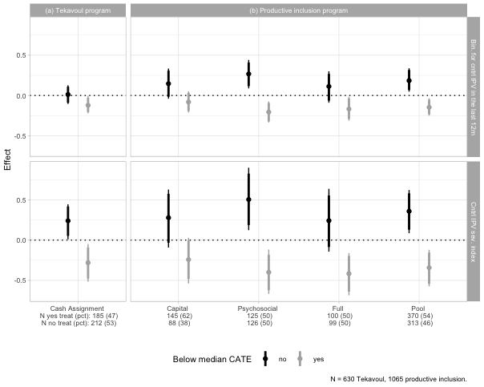

### Emotional Violence

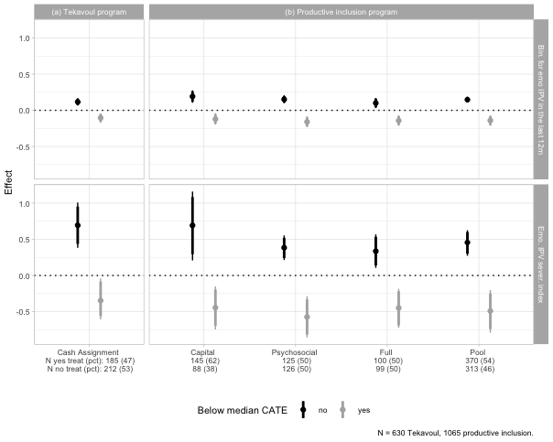

### Physical violence

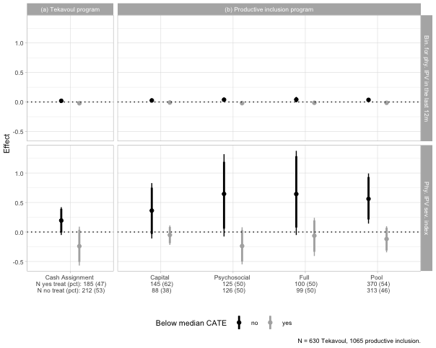

### Sexual Violence

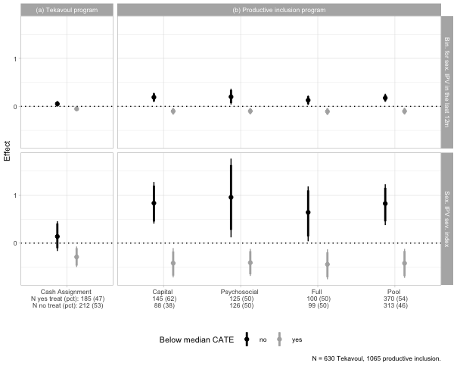

### Economic Violence

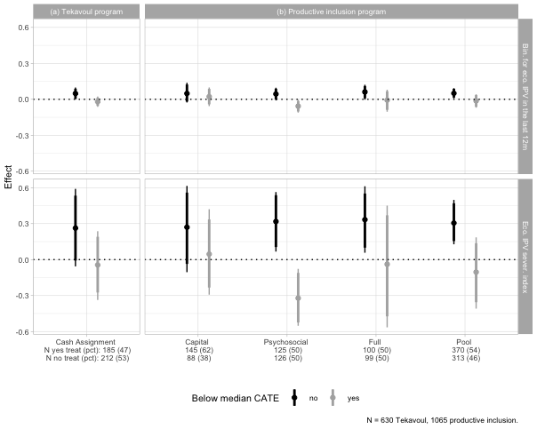

### Other types of violences

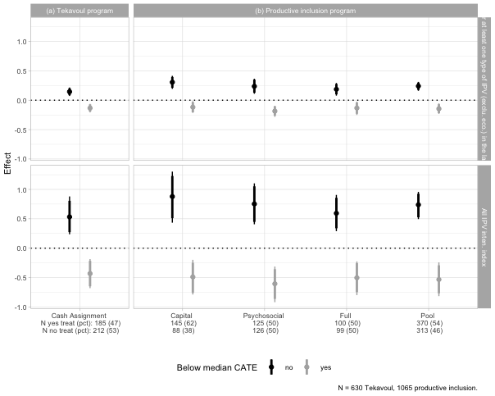

## Mechanism

### Economic Security & Emotional Well-being

Cash reduces poverty stress and improve emotional well-being. Impact: generally reduces IPV.

#### Household level

|  | (1) | (2) | (3) | (4) | (5) | (6) | (7) | (8) | (9) | (10) |
| --- | --- | --- | --- | --- | --- | --- | --- | --- | --- | --- |
| **Outcome***1* | Gross consumption (daily, USD/capita) | Food security (FIES) | Dietary diversity (FCS) | Total revenue (yearly, USD) | Business revenues (yearly, USD) | Wage earnings (yearly, USD) | Livestock revenue (yearly, USD) | Count of income sources (yearly) | No. of income sources (Household) | Wage types (Household) |
| Tekavoul |  |  |  |  |  |  |  |  |  |  |
| Control | — | — | — | — | — | — | — | — | — | — |
| Cash Assignment | 0.08 (0.206) | 0.11 (0.305) | 6.97* (3.20) | 37.87 (108) | 8.38 (87.9) | 8.76 (23.5) | 1.70 (11.2) | 0.19 (0.100) | 0.42* (0.168) | 0.00 (0.011) |
| Estimated CATE (high)* Tekavoul |  |  |  |  |  |  |  |  |  |  |
| Estimated CATE (high)* Cash Assignment | -0.27 (0.261) | -0.18 (0.435) | -5.20 (4.62) | -455.98* (228) | -511.39* (217) | -16.57 (30.2) | -1.08 (15.4) | -0.32* (0.144) | -0.64** (0.237) | 0.00 (0.015) |
| No. Obs. | 630 | 628 | 628 | 640 | 640 | 640 | 640 | 640 | 640 | 640 |
| R² | 0.099 | 0.084 | 0.039 | 0.076 | 0.077 | 0.066 | 0.011 | 0.066 | 0.047 | 0.030 |
| PI (Pool) |  |  |  |  |  |  |  |  |  |  |
| Control | — | — | — | — | — | — | — | — | — | — |
| Pool | 0.03 (0.202) | 0.26 (0.293) | 2.36 (2.80) | 70.70 (113) | 118.41 (110) | -23.90 (26.8) | -5.87 (7.86) | 0.01 (0.108) | 0.03 (0.175) | 0.00 (0.012) |
| Estimated CATE (high)* Pool |  |  |  |  |  |  |  |  |  |  |
| Estimated CATE (high)* Pool | -0.09 (0.263) | 0.09 (0.528) | -4.12 (4.01) | -20.52 (141) | -52.61 (126) | 90.27 (71.6) | 10.93 (16.1) | 0.02 (0.143) | -0.15 (0.243) | 0.00 (0.015) |
| No. Obs. | 1,040 | 1,066 | 1,066 | 1,074 | 1,074 | 1,074 | 1,074 | 1,074 | 1,074 | 1,074 |
| R² | 0.074 | 0.020 | 0.023 | 0.027 | 0.030 | 0.008 | 0.025 | 0.041 | 0.036 | 0.019 |
| Control mean @ follow up | 2.295 | 3.033 | 40.24 | 498.9 | 331.2 | 31.74 | 21.373 | 0.862 | 1.286 | 0.012 |
| Control SD @ follow up | 1.632 | 2.635 | 24.20 | 1305.7 | 1097.7 | 652.52 | 97.060 | 0.824 | 1.430 | 0.108 |
| Cash Assignment + Estimated CATE (high) * Cash Assignment | -0.192 | -0.073 | 1.77 | -418.1** | -503.0*** | -7.82 | 0.622 | -0.130 | -0.211 | 0.001 |
| Pool + Estimated CATE (high) * Pool | -0.056 | 0.354 | -1.76 | 50.2 | 65.8 | 66.36 | 5.055 | 0.033 | -0.118 | 0.006 |
| *1*Notes: Results presented are OLS estimates that include controls for randomization strata (commune) and, where possible, baseline outcomes. We control for social promotion intervention. Enumerator fixed effects are included in all regression. We estimate the regressions for the productive beneficiaries aged 18-49 only. Robust standard errors are shown in parentheses, clustered at the village proxy level. *** p < 0.01, ** p < 0.05, * p < 0.1. | | | | | | | | | | |
| Abbreviations: CI = Confidence Interval, SE = Standard Error | | | | | | | | | | |

#### Ben level

|  | Total revenue (yearly, USD) | | | Business revenues (yearly, USD) | | | Wage earnings (yearly, USD) | | | Livestock revenue (yearly, USD) | | |
| --- | --- | --- | --- | --- | --- | --- | --- | --- | --- | --- | --- | --- |
| **Outcome***1* | hh. | ben. | prt. | hh. | ben. | prt. | hh. | ben. | prt. | hh. | ben. | prt. |
| Tekavoul |  |  |  |  |  |  |  |  |  |  |  |  |
| Control | — | — | — | — | — | — | — | — | — | — | — | — |
| Cash Assignment | 37.87 (108) | 52.52 (50.6) | -14.65 (97.0) | 8.38 (87.9) | 13.67 (45.8) | -5.29 (76.4) | 8.76 (23.5) | 0.42 (0.424) | 8.34 (23.5) | 1.70 (11.2) | 4.39 (8.74) | -2.69 (6.98) |
| Estimated CATE (high)* Tekavoul |  |  |  |  |  |  |  |  |  |  |  |  |
| Estimated CATE (high)* Cash Assignment | -455.98* (228) | -376.31* (185) | -79.66 (142) | -511.39* (217) | -364.50* (184) | -146.89 (125) | -16.57 (30.2) | -0.46 (0.466) | -16.12 (30.2) | -1.08 (15.4) | -0.47 (9.23) | -0.60 (11.7) |
| No. Obs. | 640 | 640 | 640 | 640 | 640 | 640 | 640 | 640 | 640 | 640 | 640 | 640 |
| R² | 0.076 | 0.052 | 0.076 | 0.077 | 0.054 | 0.063 | 0.066 | 0.014 | 0.066 | 0.011 | 0.035 | 0.025 |
| PI (Pool) |  |  |  |  |  |  |  |  |  |  |  |  |
| Control | — | — | — | — | — | — | — | — | — | — | — | — |
| Pool | 70.70 (113) | 95.21 (96.9) | -24.51 (51.2) | 118.41 (110) | 123.68 (95.4) | -5.27 (42.1) | -23.90 (26.8) | -12.16 (14.5) | -11.74 (22.9) | -5.87 (7.86) | -3.81 (4.84) | -2.06 (5.17) |
| Estimated CATE (high)* Pool |  |  |  |  |  |  |  |  |  |  |  |  |
| Estimated CATE (high)* Pool | -20.52 (141) | 90.45 (127) | -110.97 (68.0) | -52.61 (126) | 37.41 (108) | -90.02 (58.8) | 90.27 (71.6) | 72.36 (67.7) | 17.90 (24.4) | 10.93 (16.1) | 2.83 (10.7) | 8.10 (9.18) |
| No. Obs. | 1,074 | 1,074 | 1,074 | 1,074 | 1,074 | 1,074 | 1,074 | 1,074 | 1,074 | 1,074 | 1,074 | 1,074 |
| R² | 0.027 | 0.037 | 0.059 | 0.030 | 0.036 | 0.026 | 0.008 | 0.008 | 0.022 | 0.025 | 0.023 | 0.017 |
| Control mean @ follow up | 498.9 | 268 | 231.2 | 331.2 | 202 | 129.0 | 31.74 | 19.525 | 12.22 | 21.373 | 10.832 | 10.54 |
| Control SD @ follow up | 1305.7 | 1117 | 653.0 | 1097.7 | 915 | 565.9 | 652.52 | 622.495 | 196.89 | 97.060 | 61.105 | 71.38 |
| Cash Assignment + Estimated CATE (high) * Cash Assignment | -418.1** | -324* | -94.3 | -503.0*** | -351** | -152.2 | -7.82 | -0.038 | -7.78 | 0.622 | 3.918 | -3.30 |
| Pool + Estimated CATE (high) * Pool | 50.2 | 186* | -135.5** | 65.8 | 161* | -95.3* | 66.36 | 60.203 | 6.16 | 5.055 | -0.984 | 6.04 |
| *1*Notes: Results presented are OLS estimates that include controls for randomization strata (commune) and, where possible, baseline outcomes. We control for social promotion intervention. Enumerator fixed effects are included in all regression. We estimate the regressions for the productive beneficiaries aged 18-49 only. Robust standard errors are shown in parentheses, clustered at the village proxy level. *** p < 0.01, ** p < 0.05, * p < 0.1. | | | | | | | | | | | | |
| Abbreviations: CI = Confidence Interval, SE = Standard Error | | | | | | | | | | | | |

### Intra-household Conflict

#### Main indexes

|  | (1) | (2) | (3) |
| --- | --- | --- | --- |
| **Outcome***1* | Intra-household dynamics index | Violence perceptions index | Gender attitudes index |
| Tekavoul |  |  |  |
| Control | — | — | — |
| Cash Assignment | -0.12 (0.102) | -0.05 (0.123) | -0.27** (0.097) |
| Estimated CATE (high)* Tekavoul |  |  |  |
| Estimated CATE (high)* Cash Assignment | -0.05 (0.147) | -0.03 (0.182) | 0.29 (0.170) |
| No. Obs. | 628 | 628 | 628 |
| R² | 0.045 | 0.045 | 0.056 |
| PI (Pool) |  |  |  |
| Control | — | — | — |
| Pool | -0.17* (0.084) | 0.09 (0.110) | -0.07 (0.099) |
| Estimated CATE (high)* Pool |  |  |  |
| Estimated CATE (high)* Pool | 0.07 (0.126) | -0.10 (0.126) | 0.00 (0.173) |
| No. Obs. | 1,066 | 1,066 | 1,066 |
| R² | 0.031 | 0.022 | 0.023 |
| Control mean @ follow up | 0.067 | 0.010 | -0.009 |
| Control SD @ follow up | 0.852 | 0.974 | 0.957 |
| Cash Assignment + Estimated CATE (high) * Cash Assignment | -0.165 | -0.080 | 0.015 |
| Pool + Estimated CATE (high) * Pool | -0.103 | -0.010 | -0.077 |
| *1*Notes: Results presented are OLS estimates that include controls for randomization strata (commune) and, where possible, baseline outcomes. We control for social promotion intervention. Enumerator fixed effects are included in all regression. We estimate the regressions for the productive beneficiaries aged 18-49 only. Robust standard errors are shown in parentheses, clustered at the village proxy level. *** p < 0.01, ** p < 0.05, * p < 0.1. | | | |
| Abbreviations: CI = Confidence Interval, SE = Standard Error | | | |

#### Indexes components

##### Intra-household index components

|  | (1) | (2) | (3) | (4) | (5) | (6) | (7) | (8) | (9) |
| --- | --- | --- | --- | --- | --- | --- | --- | --- | --- |
| **Outcome***1* | Intra-household dynamics index | Partner dynamics index | Household dynamics index | Comfortable disagreeing with partner (1-4) | Trusts partner (1-4) | Partner inclusiveness (1-4) | Household inclusiveness (1-4) | Household tensions infrequent (1-4) | Relationship satisfaction (1-10) |
| Tekavoul |  |  |  |  |  |  |  |  |  |
| Control | — | — | — | — | — | — | — | — | — |
| Cash Assignment | -0.12 (0.102) | -0.19 (0.103) | -0.02 (0.117) | -0.21 (0.131) | -0.09 (0.107) | -0.10 (0.096) | 0.03 (0.107) | -0.12 (0.104) | 0.65* (0.283) |
| Estimated CATE (high)* Tekavoul |  |  |  |  |  |  |  |  |  |
| Estimated CATE (high)* Cash Assignment | -0.05 (0.147) | 0.12 (0.148) | -0.16 (0.164) | 0.15 (0.174) | 0.14 (0.153) | 0.00 (0.126) | -0.14 (0.146) | 0.00 (0.142) | -1.08** (0.392) |
| No. Obs. | 628 | 588 | 628 | 570 | 576 | 576 | 628 | 586 | 628 |
| R² | 0.045 | 0.065 | 0.034 | 0.045 | 0.051 | 0.058 | 0.030 | 0.062 | 0.037 |
| PI (Pool) |  |  |  |  |  |  |  |  |  |
| Control | — | — | — | — | — | — | — | — | — |
| Pool | -0.17* (0.084) | -0.03 (0.098) | -0.26** (0.098) | -0.03 (0.111) | 0.03 (0.104) | -0.08 (0.072) | -0.28** (0.090) | -0.03 (0.087) | 0.39 (0.251) |
| Estimated CATE (high)* Pool |  |  |  |  |  |  |  |  |  |
| Estimated CATE (high)* Pool | 0.07 (0.126) | -0.12 (0.145) | 0.21 (0.136) | -0.13 (0.145) | -0.17 (0.141) | 0.06 (0.128) | 0.22 (0.148) | 0.05 (0.122) | -0.93* (0.366) |
| No. Obs. | 1,066 | 1,008 | 1,066 | 983 | 985 | 992 | 1,066 | 996 | 1,063 |
| R² | 0.031 | 0.038 | 0.033 | 0.024 | 0.030 | 0.040 | 0.053 | 0.053 | 0.030 |
| Control mean @ follow up | 0.067 | 0.108 | 0.027 | 3.101 | 3.317 | 3.520 | 3.206 | 3.368 | 4.438 |
| Control SD @ follow up | 0.852 | 0.839 | 0.982 | 0.960 | 0.848 | 0.759 | 0.883 | 0.825 | 2.261 |
| Cash Assignment + Estimated CATE (high) * Cash Assignment | -0.165 | -0.065 | -0.177 | -0.061 | 0.053 | -0.100 | -0.116 | -0.113 | -0.427 |
| Pool + Estimated CATE (high) * Pool | -0.103 | -0.149 | -0.053 | -0.161 | -0.139 | -0.023 | -0.064 | 0.024 | -0.532* |
| *1*Notes: Results presented are OLS estimates that include controls for randomization strata (commune) and, where possible, baseline outcomes. We control for social promotion intervention. Enumerator fixed effects are included in all regression. We estimate the regressions for the productive beneficiaries aged 18-49 only. Robust standard errors are shown in parentheses, clustered at the village proxy level. *** p < 0.01, ** p < 0.05, * p < 0.1. | | | | | | | | | |
| Abbreviations: CI = Confidence Interval, SE = Standard Error | | | | | | | | | |

##### Violence perception index components

|  | (1) | (2) | (3) | (4) |
| --- | --- | --- | --- | --- |
| **Outcome***1* | Violence perceptions index | Know women with HH-tension (0-10) | Women beaten for burning food (1-4) | Women beaten for neglecting children (1-4) |
| Tekavoul |  |  |  |  |
| Control | — | — | — | — |
| Cash Assignment | -0.05 (0.123) | 0.35 (0.289) | -0.03 (0.089) | -0.14 (0.085) |
| Estimated CATE (high)* Tekavoul |  |  |  |  |
| Estimated CATE (high)* Cash Assignment | -0.03 (0.182) | -0.27 (0.398) | -0.01 (0.124) | 0.04 (0.128) |
| No. Obs. | 628 | 628 | 628 | 628 |
| R² | 0.045 | 0.083 | 0.048 | 0.042 |
| PI (Pool) |  |  |  |  |
| Control | — | — | — | — |
| Pool | 0.09 (0.110) | 0.31 (0.308) | 0.01 (0.073) | 0.04 (0.075) |
| Estimated CATE (high)* Pool |  |  |  |  |
| Estimated CATE (high)* Pool | -0.10 (0.126) | -0.51 (0.417) | 0.02 (0.105) | -0.02 (0.098) |
| No. Obs. | 1,066 | 1,066 | 1,066 | 1,066 |
| R² | 0.022 | 0.060 | 0.019 | 0.014 |
| Control mean @ follow up | 0.010 | 3.152 | 1.349 | 1.342 |
| Control SD @ follow up | 0.974 | 2.398 | 0.698 | 0.677 |
| Cash Assignment + Estimated CATE (high) * Cash Assignment | -0.080 | 0.077 | -0.041 | -0.095 |
| Pool + Estimated CATE (high) * Pool | -0.010 | -0.198 | 0.025 | 0.016 |
| *1*Notes: Results presented are OLS estimates that include controls for randomization strata (commune) and, where possible, baseline outcomes. We control for social promotion intervention. Enumerator fixed effects are included in all regression. We estimate the regressions for the productive beneficiaries aged 18-49 only. Robust standard errors are shown in parentheses, clustered at the village proxy level. *** p < 0.01, ** p < 0.05, * p < 0.1. | | | | |
| Abbreviations: CI = Confidence Interval, SE = Standard Error | | | | |

##### Gender attitude index components

|  | (1) | (2) | (3) | (4) | (5) | (6) |
| --- | --- | --- | --- | --- | --- | --- |
| **Outcome***1* | Gender attitudes index | Food violence is NOT OK (0,1) | Children violence is NOT OK (0,1) | Should NOT tolerate violence (1-4) | NOT only men should work (1-4) | Should school girls (1-4) |
| Tekavoul |  |  |  |  |  |  |
| Control | — | — | — | — | — | — |
| Cash Assignment | -0.27** (0.097) | -0.03 (0.024) | -0.03 (0.029) | -0.38*** (0.111) | -0.22* (0.101) | 0.24* (0.098) |
| Estimated CATE (high)* Tekavoul |  |  |  |  |  |  |
| Estimated CATE (high)* Cash Assignment | 0.29 (0.170) | 0.07 (0.045) | 0.08 (0.051) | 0.24 (0.157) | 0.17 (0.147) | -0.29 (0.148) |
| No. Obs. | 628 | 628 | 628 | 628 | 628 | 628 |
| R² | 0.056 | 0.066 | 0.052 | 0.049 | 0.047 | 0.047 |
| PI (Pool) |  |  |  |  |  |  |
| Control | — | — | — | — | — | — |
| Pool | -0.07 (0.099) | -0.02 (0.025) | -0.01 (0.033) | 0.04 (0.089) | -0.14 (0.096) | 0.04 (0.094) |
| Estimated CATE (high)* Pool |  |  |  |  |  |  |
| Estimated CATE (high)* Pool | 0.00 (0.173) | -0.05 (0.044) | -0.03 (0.053) | 0.09 (0.132) | 0.29* (0.128) | -0.12 (0.118) |
| No. Obs. | 1,066 | 1,066 | 1,066 | 1,066 | 1,066 | 1,066 |
| R² | 0.023 | 0.033 | 0.018 | 0.027 | 0.028 | 0.028 |
| Control mean @ follow up | -0.009 | 0.925 | 0.909 | 2.450 | 2.599 | 2.389 |
| Control SD @ follow up | 0.957 | 0.264 | 0.288 | 0.883 | 0.838 | 0.859 |
| Cash Assignment + Estimated CATE (high) * Cash Assignment | 0.015 | 0.041 | 0.048 | -0.142 | -0.056 | -0.048 |
| Pool + Estimated CATE (high) * Pool | -0.077 | -0.074 | -0.040 | 0.135 | 0.147 | -0.083 |
| *1*Notes: Results presented are OLS estimates that include controls for randomization strata (commune) and, where possible, baseline outcomes. We control for social promotion intervention. Enumerator fixed effects are included in all regression. We estimate the regressions for the productive beneficiaries aged 18-49 only. Robust standard errors are shown in parentheses, clustered at the village proxy level. *** p < 0.01, ** p < 0.05, * p < 0.1. | | | | | | |
| Abbreviations: CI = Confidence Interval, SE = Standard Error | | | | | | |

##### Social norm index components

|  | (1) | (2) | (3) | (4) | (5) | (6) | (7) | (8) | (9) | (10) | (11) |
| --- | --- | --- | --- | --- | --- | --- | --- | --- | --- | --- | --- |
| **Outcome***1* | Social norms index | Descriptive norms index | Know women travel freely (0-10) | Know women with loans (0-10) | Know women who started activities (0-10) | Know women travel freely (0-10) | Prescriptive norms index | No. men who think women shd travel freely (0-10) | No. men who think women shd have own work (0-10) | No. women who think women shd travel freely (0-10) | No. women who think women shd have own work (0-10) |
| Tekavoul |  |  |  |  |  |  |  |  |  |  |  |
| Control | — | — | — | — | — | — | — | — | — | — | — |
| Cash Assignment | 0.01 (0.117) | 0.11 (0.117) | 0.51 (0.262) | 0.05 (0.263) | -0.14 (0.272) | 0.37 (0.282) | -0.10 (0.114) | -0.25 (0.292) | -0.45 (0.265) | -0.03 (0.288) | -0.02 (0.271) |
| Estimated CATE (high)* Tekavoul |  |  |  |  |  |  |  |  |  |  |  |
| Estimated CATE (high)* Cash Assignment | 0.09 (0.168) | -0.19 (0.157) | -0.28 (0.345) | 0.00 (0.348) | -0.41 (0.370) | -0.75 (0.401) | 0.27 (0.163) | 0.39 (0.434) | 0.96* (0.393) | -0.02 (0.418) | 0.70 (0.377) |
| No. Obs. | 628 | 628 | 628 | 628 | 628 | 628 | 628 | 628 | 628 | 628 | 628 |
| R² | 0.076 | 0.131 | 0.107 | 0.129 | 0.067 | 0.083 | 0.068 | 0.045 | 0.067 | 0.042 | 0.099 |
| PI (Pool) |  |  |  |  |  |  |  |  |  |  |  |
| Control | — | — | — | — | — | — | — | — | — | — | — |
| Pool | 0.34** (0.120) | 0.38** (0.140) | 0.82** (0.273) | 0.67* (0.277) | 0.69* (0.299) | 0.56 (0.332) | -0.10 (0.110) | -0.27 (0.255) | -0.28 (0.287) | 0.08 (0.263) | -0.28 (0.317) |
| Estimated CATE (high)* Pool |  |  |  |  |  |  |  |  |  |  |  |
| Estimated CATE (high)* Pool | -0.27* (0.130) | -0.45* (0.182) | -1.23** (0.399) | -0.99* (0.391) | -0.50 (0.353) | -0.52 (0.371) | 0.23 (0.169) | 0.30 (0.368) | 0.63 (0.376) | 0.17 (0.412) | 0.62 (0.369) |
| No. Obs. | 1,066 | 1,066 | 1,066 | 1,066 | 1,066 | 1,066 | 1,066 | 1,066 | 1,066 | 1,066 | 1,066 |
| R² | 0.044 | 0.125 | 0.114 | 0.112 | 0.070 | 0.076 | 0.069 | 0.021 | 0.067 | 0.037 | 0.092 |
| Control mean @ follow up | -0.009 | 0.028 | 2.975 | 3.001 | 2.987 | 3.160 | -0.036 | 6.385 | 6.663 | 6.355 | 6.746 |
| Control SD @ follow up | 1.001 | 1.000 | 2.194 | 2.214 | 2.256 | 2.386 | 0.979 | 2.630 | 2.273 | 2.552 | 2.304 |
| Cash Assignment + Estimated CATE (high) * Cash Assignment | 0.107 | -0.084 | 0.224 | 0.052 | -0.552** | -0.373 | 0.172 | 0.142 | 0.506* | -0.049 | 0.682*** |
| Pool + Estimated CATE (high) * Pool | 0.065 | -0.073 | -0.411 | -0.321 | 0.191 | 0.037 | 0.127 | 0.032 | 0.346 | 0.244 | 0.337 |
| *1*Notes: Results presented are OLS estimates that include controls for randomization strata (commune) and, where possible, baseline outcomes. We control for social promotion intervention. Enumerator fixed effects are included in all regression. We estimate the regressions for the productive beneficiaries aged 18-49 only. Robust standard errors are shown in parentheses, clustered at the village proxy level. *** p < 0.01, ** p < 0.05, * p < 0.1. | | | | | | | | | | | |
| Abbreviations: CI = Confidence Interval, SE = Standard Error | | | | | | | | | | | |

### Women’s bargaining power

#### Decision making

|  | (1) | (2) | (3) | (4) | (5) | (6) | (7) | (8) | (9) | (10) | (11) | (12) | (13) | (14) | (15) | (16) | (17) |
| --- | --- | --- | --- | --- | --- | --- | --- | --- | --- | --- | --- | --- | --- | --- | --- | --- | --- |
| **Outcome***1* | Control over household resources index | Control over earnings index | Own earnings influence (1-3) | Can Decide to Earn Alone (1-3) | Agriculture influence (1-3) | Livestock influence (1-3) | Off-farm business influence (1-3) | Daily spending influence (1-3) | Can Decide to Spend Alone (1-3) | Large purchases influence (1-3) | Can Decide to Spend Large Amounts Alone (1-3) | Family planning influence (1-3) | Can Make Fertility Choices Alone (1-3) | Own healthcare influence (1-3) | Can Decide about Self-Care Alone (1-3) | Partner’s earnings influence (1-3) | Child education influence (1-3) |
| Tekavoul |  |  |  |  |  |  |  |  |  |  |  |  |  |  |  |  |  |
| Control | — | — | — | — | — | — | — | — | — | — | — | — | — | — | — | — | — |
| Cash Assignment | 0.13 (0.115) | 0.06 (0.115) | 0.01 (0.085) | 0.17 (0.098) | 0.16 (0.086) | 0.08 (0.102) | 0.18 (0.099) | 0.02 (0.078) | 0.17 (0.100) | -0.03 (0.082) | 0.18 (0.099) | 0.07 (0.102) | 0.24* (0.115) | 0.03 (0.071) | 0.20* (0.099) | 0.08 (0.088) | 0.02 (0.073) |
| Estimated CATE (high)* Tekavoul |  |  |  |  |  |  |  |  |  |  |  |  |  |  |  |  |  |
| Estimated CATE (high)* Cash Assignment | -0.11 (0.167) | -0.03 (0.171) | 0.10 (0.112) | -0.28* (0.143) | -0.27* (0.119) | -0.23 (0.138) | -0.35** (0.134) | 0.05 (0.100) | -0.25 (0.139) | 0.10 (0.105) | -0.18 (0.137) | -0.06 (0.142) | -0.32* (0.163) | 0.05 (0.094) | -0.20 (0.138) | -0.10 (0.123) | 0.06 (0.098) |
| No. Obs. | 586 | 640 | 563 | 558 | 510 | 414 | 441 | 568 | 575 | 572 | 578 | 447 | 454 | 584 | 584 | 554 | 583 |
| R² | 0.134 | 0.100 | 0.042 | 0.051 | 0.062 | 0.050 | 0.074 | 0.039 | 0.037 | 0.046 | 0.048 | 0.040 | 0.049 | 0.034 | 0.045 | 0.042 | 0.052 |
| PI (Pool) |  |  |  |  |  |  |  |  |  |  |  |  |  |  |  |  |  |
| Control | — | — | — | — | — | — | — | — | — | — | — | — | — | — | — | — | — |
| Pool | -0.13 (0.105) | -0.03 (0.125) | 0.06 (0.066) | 0.25** (0.093) | 0.06 (0.080) | -0.09 (0.090) | -0.01 (0.083) | 0.05 (0.060) | 0.15 (0.088) | 0.06 (0.061) | 0.13 (0.085) | 0.16 (0.087) | 0.21* (0.093) | 0.06 (0.057) | 0.16* (0.079) | 0.04 (0.078) | 0.03 (0.060) |
| Estimated CATE (high)* Pool |  |  |  |  |  |  |  |  |  |  |  |  |  |  |  |  |  |
| Estimated CATE (high)* Pool | -0.20 (0.173) | -0.12 (0.128) | -0.12 (0.108) | -0.49*** (0.124) | -0.13 (0.104) | -0.06 (0.126) | -0.15 (0.115) | -0.26** (0.100) | -0.34** (0.117) | -0.20* (0.100) | -0.31** (0.101) | -0.28 (0.145) | -0.38** (0.130) | -0.27** (0.093) | -0.35** (0.113) | -0.12 (0.113) | -0.16 (0.101) |
| No. Obs. | 1,032 | 1,074 | 973 | 950 | 850 | 681 | 705 | 971 | 972 | 975 | 977 | 787 | 786 | 987 | 984 | 950 | 979 |
| R² | 0.163 | 0.116 | 0.035 | 0.093 | 0.049 | 0.039 | 0.046 | 0.043 | 0.062 | 0.042 | 0.051 | 0.036 | 0.043 | 0.049 | 0.066 | 0.042 | 0.027 |
| Control mean @ follow up | -0.082 | -0.078 | 2.594 | 2.315 | 2.571 | 2.505 | 2.496 | 2.676 | 2.355 | 2.646 | 2.380 | 2.492 | 2.173 | 2.725 | 2.392 | 2.476 | 2.709 |
| Control SD @ follow up | 0.981 | 1.075 | 0.614 | 0.782 | 0.626 | 0.650 | 0.651 | 0.554 | 0.768 | 0.560 | 0.764 | 0.674 | 0.796 | 0.498 | 0.761 | 0.671 | 0.517 |
| Cash Assignment + Estimated CATE (high) * Cash Assignment | 0.020 | 0.024 | 0.105 | -0.111 | -0.112 | -0.151* | -0.177** | 0.077 | -0.077 | 0.069 | -0.001 | 0.012 | -0.081 | 0.082 | 0.001 | -0.016 | 0.081 |
| Pool + Estimated CATE (high) * Pool | -0.321** | -0.151* | -0.057 | -0.236** | -0.078 | -0.141 | -0.161 | -0.210** | -0.197** | -0.135 | -0.182** | -0.118 | -0.166* | -0.207** | -0.185** | -0.074 | -0.123 |
| *1*Notes: Results presented are OLS estimates that include controls for randomization strata (commune) and, where possible, baseline outcomes. We control for social promotion intervention. Enumerator fixed effects are included in all regression. We estimate the regressions for the productive beneficiaries aged 18-49 only. Robust standard errors are shown in parentheses, clustered at the village proxy level. *** p < 0.01, ** p < 0.05, * p < 0.1. | | | | | | | | | | | | | | | | | |
| Abbreviations: CI = Confidence Interval, SE = Standard Error | | | | | | | | | | | | | | | | | |

#### Empowerment

|  | (1) | (2) | (3) | (4) | (5) | (6) | (7) | (8) | (9) | (10) | (11) | (12) | (13) | (14) | (15) | (16) | (17) | (18) |
| --- | --- | --- | --- | --- | --- | --- | --- | --- | --- | --- | --- | --- | --- | --- | --- | --- | --- | --- |
| **Outcome***1* | Can Decide to Earn Alone (1-4) | Wage earnings (yearly, USD) | Benef. controls crop revenue (0,1) | No. of beneficiary businesses | Beneficiary has a business (0,1) | No. of months benef worked last year | Entrepreneurial business types (yearly) | Beneficiary launched a business (0,1) | Beneficiary abandoned a business (0,1) | Personnal savings | Business revenues (yearly, USD) | Business profits (yearly, USD) | Business asset value (USD) | Beneficiary investments (yearly, USD) | Business revenue (beneficiary, monthly, USD) | Benef. owns livestock (0,1) | Benef. controls livestock revenue (0,1) | Benef. traveled for work (0,1) |
| Tekavoul |  |  |  |  |  |  |  |  |  |  |  |  |  |  |  |  |  |  |
| Control | — | — | — | — | — | — | — | — | — | — | — | — | — | — | — | — | — | — |
| Cash Assignment | 0.17 (0.098) | 0.42 (0.424) | 0.04* (0.020) | 0.01 (0.042) | 0.01 (0.038) | -0.05 (0.300) | 0.01 (0.038) | 0.00 (0.025) | -0.03 (0.022) | -0.06 (2.31) | 13.67 (45.8) | -9.46 (26.3) | 3.86 (2.00) | 4.44 (3.53) | 2.13 (4.66) | 0.03 (0.029) | 0.04 (0.027) | 0.00 (0.001) |
| Estimated CATE (high)* Tekavoul |  |  |  |  |  |  |  |  |  |  |  |  |  |  |  |  |  |  |
| Estimated CATE (high)* Cash Assignment | -0.28* (0.143) | -0.46 (0.466) | -0.05 (0.028) | -0.11 (0.078) | -0.09 (0.061) | -1.06 (0.623) | -0.09 (0.061) | -0.01 (0.037) | 0.01 (0.029) | -2.21 (5.15) | -364.50* (184) | -175.90 (94.2) | -6.06 (5.54) | -7.51 (6.63) | -26.88 (15.0) | 0.00 (0.043) | -0.03 (0.033) | -0.02 (0.011) |
| No. Obs. | 558 | 640 | 640 | 640 | 640 | 640 | 640 | 640 | 640 | 640 | 640 | 640 | 640 | 640 | 640 | 640 | 640 | 640 |
| R² | 0.051 | 0.014 | 0.028 | 0.064 | 0.057 | 0.073 | 0.057 | 0.037 | 0.019 | 0.051 | 0.054 | 0.057 | 0.021 | 0.046 | 0.062 | 0.031 | 0.041 | 0.031 |
| PI (Pool) |  |  |  |  |  |  |  |  |  |  |  |  |  |  |  |  |  |  |
| Control | — | — | — | — | — | — | — | — | — | — | — | — | — | — | — | — | — | — |
| Pool | 0.25** (0.093) | -12.16 (14.5) | 0.00 (0.018) | 0.17** (0.054) | 0.14** (0.050) | 0.85* (0.397) | 0.15** (0.051) | 0.03 (0.024) | 0.06* (0.024) | 4.63 (3.67) | 123.68 (95.4) | 48.40 (43.5) | 7.18 (4.24) | 30.59*** (7.74) | 15.78 (10.3) | -0.04 (0.033) | -0.02 (0.021) | 0.01 (0.006) |
| Estimated CATE (high)* Pool |  |  |  |  |  |  |  |  |  |  |  |  |  |  |  |  |  |  |
| Estimated CATE (high)* Pool | -0.49*** (0.124) | 72.36 (67.7) | -0.03 (0.030) | -0.08 (0.059) | -0.05 (0.051) | -0.10 (0.458) | -0.05 (0.052) | -0.01 (0.030) | -0.02 (0.025) | -1.08 (5.07) | 37.41 (108) | 23.24 (49.8) | -4.30 (7.36) | -15.80 (9.00) | -2.45 (11.1) | 0.03 (0.037) | 0.00 (0.036) | -0.01 (0.005) |
| No. Obs. | 950 | 1,074 | 1,074 | 1,074 | 1,074 | 1,074 | 1,074 | 1,074 | 1,074 | 1,074 | 1,074 | 1,074 | 1,074 | 1,074 | 1,074 | 1,074 | 1,074 | 1,074 |
| R² | 0.093 | 0.008 | 0.014 | 0.060 | 0.066 | 0.046 | 0.066 | 0.017 | 0.038 | 0.029 | 0.036 | 0.029 | 0.026 | 0.058 | 0.042 | 0.019 | 0.020 | 0.022 |
| Control mean @ follow up | 2.315 | 19.525 | 0.042 | 0.160 | 0.149 | 1.192 | 0.149 | 0.047 | 0.021 | 6.71 | 202 | 95.2 | 6.23 | 14.08 | 19.4 | 0.082 | 0.052 | 0.003 |
| Control SD @ follow up | 0.782 | 622.495 | 0.201 | 0.395 | 0.356 | 3.453 | 0.356 | 0.212 | 0.144 | 36.06 | 915 | 457.5 | 55.63 | 52.66 | 86.6 | 0.274 | 0.223 | 0.050 |
| Cash Assignment + Estimated CATE (high) * Cash Assignment | -0.111 | -0.038 | -0.005 | -0.104* | -0.082* | -1.114** | -0.082* | -0.018 | -0.015 | -2.27 | -351** | -185.4** | -2.20 | -3.07 | -24.8* | 0.026 | 0.005 | -0.018 |
| Pool + Estimated CATE (high) * Pool | -0.236** | 60.203 | -0.024 | 0.089** | 0.095** | 0.752** | 0.098** | 0.021 | 0.043*** | 3.55 | 161* | 71.6* | 2.87 | 14.79** | 13.3 | -0.003 | -0.023 | 0.001 |
| *1*Notes: Results presented are OLS estimates that include controls for randomization strata (commune) and, where possible, baseline outcomes. We control for social promotion intervention. Enumerator fixed effects are included in all regression. We estimate the regressions for the productive beneficiaries aged 18-49 only. Robust standard errors are shown in parentheses, clustered at the village proxy level. *** p < 0.01, ** p < 0.05, * p < 0.1. | | | | | | | | | | | | | | | | | | |
| Abbreviations: CI = Confidence Interval, SE = Standard Error | | | | | | | | | | | | | | | | | | |

### Intensive time use

#### Grouping time use variables

|  | (1) | (2) | (3) |
| --- | --- | --- | --- |
| **Outcome***1* | Tot Mins in household chores | Tot Mins in outhouse income generating activities | Tot Mins in leisure activities |
| Tekavoul |  |  |  |
| Control | — | — | — |
| Cash Assignment | 70.95 (256) | -9.52 (72.0) | 206.67* (84.5) |
| Estimated CATE (high)* Tekavoul |  |  |  |
| Estimated CATE (high)* Cash Assignment | 482.94 (374) | 121.18 (97.0) | -119.25 (110) |
| No. Obs. | 640 | 640 | 640 |
| R² | 0.056 | 0.022 | 0.025 |
| PI (Pool) |  |  |  |
| Control | — | — | — |
| Pool | -173.56 (204) | 184.12 (101) | 105.63 (102) |
| Estimated CATE (high)* Pool |  |  |  |
| Estimated CATE (high)* Pool | -356.94 (376) | -169.79 (100) | -263.37* (125) |
| No. Obs. | 1,074 | 1,074 | 1,074 |
| R² | 0.061 | 0.016 | 0.013 |
| Control mean @ follow up | 1809 | 202.7 | 611.3 |
| Control SD @ follow up | 2301 | 637.2 | 772.1 |
| Cash Assignment + Estimated CATE (high) * Cash Assignment | 554** | 111.7* | 87.4 |
| Pool + Estimated CATE (high) * Pool | -530 | 14.3 | -157.7* |
| *1*Notes: Results presented are OLS estimates that include controls for randomization strata (commune) and, where possible, baseline outcomes. We control for social promotion intervention. Enumerator fixed effects are included in all regression. We estimate the regressions for the productive beneficiaries aged 18-49 only. Robust standard errors are shown in parentheses, clustered at the village proxy level. *** p < 0.01, ** p < 0.05, * p < 0.1. | | | |
| Abbreviations: CI = Confidence Interval, SE = Standard Error | | | |

#### All variables

|  | (1) | (2) | (3) | (4) | (5) | (6) | (7) | (8) | (9) | (10) | (11) | (12) | (13) | (14) | (15) | (16) | (17) | (18) | (19) |
| --- | --- | --- | --- | --- | --- | --- | --- | --- | --- | --- | --- | --- | --- | --- | --- | --- | --- | --- | --- |
| **Outcome***1* | Mins in off-farm business | Mins spent retrieving water | Mins spent cooking | Mins spent agriculture | Mins spent gathering firewood | Mins spent cleaning | Mins studying for Koranic school | Mins spent doing laundry | Mins in livestock | Mins studying for traditional school | Mins spent shopping | Mins spent child care | Mins helping handicapped relatives | Mins spent with friends | Mins spent listening radio | Mins spent resting | Mins studying for traditional school | Mins spent shopping | Mins spent praying |
| Tekavoul |  |  |  |  |  |  |  |  |  |  |  |  |  |  |  |  |  |  |  |
| Control | — | — | — | — | — | — | — | — | — | — | — | — | — | — | — | — | — | — | — |
| Cash Assignment | 30.61 (48.6) | 131.75** (49.4) | -39.52 (50.6) | -17.43 (45.3) | 29.07 (38.9) | 21.03 (23.7) | 13.16 (23.0) | 15.60 (20.0) | -19.48 (23.9) | 17.43 (21.4) | -2.50 (31.6) | -96.05 (195) | 16.82 (19.7) | 29.87 (20.4) | -3.04 (21.7) | 121.37** (45.9) | 17.43 (21.4) | -2.50 (31.6) | 38.95 (29.2) |
| Estimated CATE (high)* Tekavoul |  |  |  |  |  |  |  |  |  |  |  |  |  |  |  |  |  |  |  |
| Estimated CATE (high)* Cash Assignment | -25.63 (62.0) | -5.41 (64.0) | 131.49 (75.7) | 97.00 (56.5) | 41.00 (51.8) | 15.63 (26.4) | 4.29 (27.0) | 46.56 (27.4) | 51.87 (35.3) | -8.91 (30.2) | -5.84 (41.8) | 252.11 (291) | -9.41 (36.8) | 1.73 (29.3) | 28.64 (23.5) | -132.60* (60.7) | -8.91 (30.2) | -5.84 (41.8) | -22.05 (38.9) |
| No. Obs. | 628 | 628 | 628 | 628 | 628 | 628 | 628 | 628 | 628 | 628 | 628 | 628 | 628 | 628 | 628 | 628 | 628 | 628 | 628 |
| R² | 0.014 | 0.058 | 0.067 | 0.060 | 0.083 | 0.049 | 0.013 | 0.065 | 0.024 | 0.023 | 0.037 | 0.052 | 0.026 | 0.048 | 0.035 | 0.022 | 0.023 | 0.037 | 0.020 |
| PI (Pool) |  |  |  |  |  |  |  |  |  |  |  |  |  |  |  |  |  |  |  |
| Control | — | — | — | — | — | — | — | — | — | — | — | — | — | — | — | — | — | — | — |
| Pool | 51.48 (38.5) | 16.71 (43.2) | -9.32 (48.2) | 167.56* (75.3) | 33.58 (38.5) | 16.85 (19.8) | 51.15** (17.3) | 25.46 (23.1) | -29.15 (26.1) | 20.53 (17.6) | 31.45 (35.8) | -248.46 (149) | -17.15 (23.1) | -8.75 (25.2) | -9.09 (21.3) | 37.96 (67.1) | 20.53 (17.6) | 31.45 (35.8) | 25.40 (28.6) |
| Estimated CATE (high)* Pool |  |  |  |  |  |  |  |  |  |  |  |  |  |  |  |  |  |  |  |
| Estimated CATE (high)* Pool | -84.63 (61.1) | -152.88* (59.8) | 22.08 (60.9) | -125.40 (67.8) | -13.71 (49.2) | -44.55 (27.9) | -85.30** (31.3) | -32.13 (28.3) | 30.83 (29.9) | -54.53* (25.0) | -40.04 (48.7) | -126.29 (284) | -10.59 (27.3) | -26.14 (30.6) | 16.27 (24.1) | -85.35 (74.2) | -54.53* (25.0) | -40.04 (48.7) | -51.28 (38.9) |
| No. Obs. | 1,066 | 1,066 | 1,066 | 1,066 | 1,066 | 1,066 | 1,066 | 1,066 | 1,066 | 1,066 | 1,066 | 1,066 | 1,066 | 1,066 | 1,066 | 1,066 | 1,066 | 1,066 | 1,066 |
| R² | 0.009 | 0.045 | 0.039 | 0.021 | 0.036 | 0.023 | 0.032 | 0.045 | 0.015 | 0.020 | 0.016 | 0.045 | 0.020 | 0.027 | 0.021 | 0.010 | 0.020 | 0.016 | 0.018 |
| Control mean @ follow up | 90.83 | 274 | 435.4 | 74.0 | 189.8 | 89.7 | 41.9 | 109.03 | 40.99 | 34.69 | 102.86 | 592 | 43.23 | 102.1 | 40.88 | 196.3 | 34.69 | 102.86 | 204.9 |
| Control SD @ follow up | 427.59 | 431 | 462.7 | 382.9 | 334.9 | 171.3 | 191.7 | 198.91 | 202.21 | 198.43 | 267.22 | 1677 | 230.73 | 185.7 | 164.12 | 410.3 | 198.43 | 267.22 | 256.0 |
| Cash Assignment + Estimated CATE (high) * Cash Assignment | 4.98 | 126*** | 92.0 | 79.6** | 70.1** | 36.7*** | 17.4 | 62.16*** | 32.38 | 8.52 | -8.33 | 156 | 7.41 | 31.6 | 25.60** | -11.2 | 8.52 | -8.33 | 16.9 |
| Pool + Estimated CATE (high) * Pool | -33.15 | -136** | 12.8 | 42.2 | 19.9 | -27.7 | -34.1 | -6.67 | 1.68 | -34.00* | -8.59 | -375 | -27.74 | -34.9 | 7.18 | -47.4 | -34.00* | -8.59 | -25.9 |
| *1*Notes: Results presented are OLS estimates that include controls for randomization strata (commune) and, where possible, baseline outcomes. We control for social promotion intervention. Enumerator fixed effects are included in all regression. We estimate the regressions for the productive beneficiaries aged 18-49 only. Robust standard errors are shown in parentheses, clustered at the village proxy level. *** p < 0.01, ** p < 0.05, * p < 0.1. | | | | | | | | | | | | | | | | | | | |
| Abbreviations: CI = Confidence Interval, SE = Standard Error | | | | | | | | | | | | | | | | | | | |